**Parent/Carer information – 11/04/2025**

**Welsh Phrase of Week**

**Pasg Hapus**

**Happy Easter**

**Right of the month**

**Article 7**

**Right to Food, Water and Medical Care**

**Value of the month**

**Happiness**

Dear Parents/Carers, Annwyl Rhieni/Sy'n ofalwyr,

**End of spring term**

We finish at 1:30pm for the end of the spring term. We wish you all an Easter filled with relaxation, fun and sunshine. We look forward to seeing you all when we return to school on Monday 28th April.

**Spring Attendance Awards**

Due to an IT issue, we were unable to present awards for Spring Attendance today. These will be awarded in Celebration Assembly on Friday 2nd May.

**Easter at Cwmffrwdoer**

Thank you to Reverend Branwen from Ebenezer Chapel for visiting us this week and leading our Easter Service in school. The children enjoyed the assembly and Reverend Branwen brought an Easter edible treat in for every child. We look forward to more assemblies with Reverend Branwen.

**PTFA Easter Raffle**

Thank you for supporting the PTFA Easter Raffle. Your generous donations were included in the prizes which were awarded yesterday.

There were 9 prizes per class! Thank you to the PTFA for organising and parents/carers for donating.



A special thank you to A.I.R Cladding Ltd for their donation of Easter eggs

A fantastic sum of £730.80 was raised!

**Cwmffrwdoer Walk to school week**

It was lovely to see so many of you get involved and join us walking to school this week for the first walk to school week. Numbers increased daily and it was a lovely start to the day.

The national walk to school week is on May so look out for that if you want to join us.

**Good Luck Mrs Maguire!**

As the London Marathon gets nearer, I know many of you are raising funds for Mrs Maguire’s efforts and the London Mini-Marathon where children will run 2 miles funds raised will go towards outdoor play equipment to enhance children’s breaktimes. Unfortunately, we are unable to bank cash into school funds to make major purchases. All fundraising needs to be through Civica Pay for this reason. We hope you will still support us.

The images below show the two structures that we would like to purchase. There will be prizes for most monies raised.

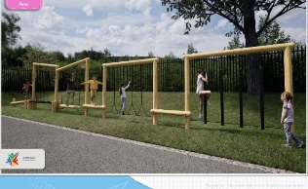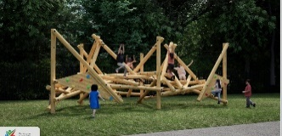



**Good luck Mrs Maguire, we will be supporting you all the way!**



[This Photo](https://www.printables.com/model/576807-painted-rubber-ducky/files) by Unknown Author is licensed under [CC BY](https://creativecommons.org/licenses/by/3.0/)

**Cwmffrwdoer Easter Duck Race**

Thank you for supporting the duck race today. We had lots of fun with class races and prizes for every class winner donated by Appollo Supply Agency.

We made a total of £131 for school funds to be spent on events throughout the year.

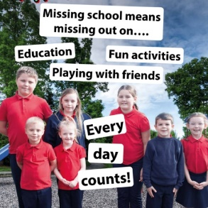

**Attendance**

**#NotInMissOut**

Regular and punctual attendance at school or alternative provision is a legal requirement and is essential to enable children to maximise their educational attainments and opportunities available to them.

Unless pupils are unwell, they should be in school.

**Fixed Penalty Notices (FPN)**

Fixed Penalty Notices will be issued 10 sessions (5 days) of unauthorised absences.

Please note that no absences will be authorised unless attendance is 95% or above.

Class attendance is rewarded weekly with the Class Attendance Cup and a non-uniform day and squash and biscuits.

**Attendance Figures - Strive for 95%**

Our attendance target is 95% for whole school.

|  |  |
| --- | --- |
| Whole School Attendance | 93% |

|  |  |  |
| --- | --- | --- |
| Class | **% Weekly Attendance** |   **Barfundle and Rhosilli**  **will have non-uniform day on Friday 2nd May** |
| Dosbarth Pebble | **86.3** |
| Dosbarth Poppit Sands | 89.7 |
| Dosbarth BaraFundle | 98.3 |
| Dosbarth Ogmore | 85.6 |
| Dosbarth Tresaith | 87.3 |
| Dosbarth Aberdovey | 90.7 |
| Dosbarth Pwll Du | 92.7 |
| Dosbarth Rhossili | 98.3 |
| Dosbarth Abersoch | 90.5 |
|  | |

**Coffee and Chat with Cheryl Deneen – Understanding and Supporting Your Child 7th May 9:15am**

We are pleased to invite parents and carers to our informal **‘Coffee and Chat’** session with **Cheryl Deneen, the Torfaen ASD Officer**. This is a relaxed opportunity to meet with other families and chat about social communication, social skills, and supporting children in social situations.

You do not need to have a child with a diagnosis to attend—whether you're looking for advice, have questions, or just want to connect with others facing similar challenges, everyone is welcome.

Join us for a friendly and supportive conversation over a cup of tea or coffee. We look forward to seeing you there!

**Diary Dates for Spring and Summer term.**

|  |  |
| --- | --- |
| **April** | Value of month - Happiness  Mathematics and Statistics Awareness Month |
| **2/04/25** | World Autism Awareness Day |
| **14/04 –25/04/25** | Easter holidays |
| **28/04/25** | Return to school summer term |
| **May** | Value of Month - Honesty |
| **5/05/25** | May Day Bank holiday |
| **6/05/25** | INSET day – closed to pupils |
| **7/05/25** | Coffee and Chat Morning with Cheryl Deneen (Torfaen ASD Officer) |
| **19/5/25** | Walk to School Week |
| **23/5/25** | End of half term – FINISH NORMAL TIME |
| **26/5 – 30/5/25** | Half term |
| **2/06/25** | INSET day – school closed to children |
| **June** | Value of Month - Diversity |
| **3/06/25** | School reopens for children |
| **22/06/25** | Windrush Day |
| **July** | Value of Month - Community |
| **3/07/25** | **Sports Day events:**  10am – Years 3/4  1Pm – Year 5/6 |
| **4/07/25** | 10am – Nursery & Reception  1:30pm – Years 1/2 |
| **Saturday O5/07/25** | Summer Fete – 11am |
| **18/07/25** | End of Summer Term for children - FINISH AT 1:30PM |
| **21/07/25** | INSET day for staff |

Cofion Cynnes,

Sarah Truelove Roque

Headteacher